OS Lab Report – Week 12 & 13

Synchronisation & Disk Management

PES1201800366

Aditeya Baral

**1. Week 12**

Write a C program to implement the solution to Dining-Philosophers problem.

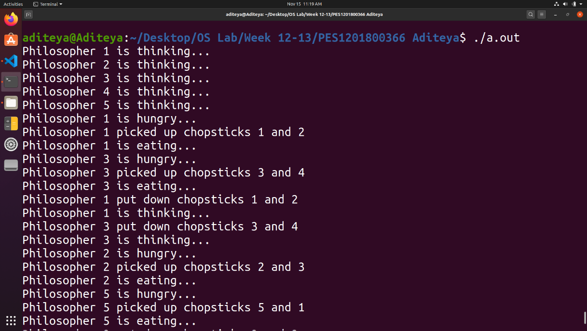

**2. Week 13**

Write a C program to implement FCFS disk scheduling.

